# **EMPLOYEE MANAGEMENT SYSTEM**

# **Name : Karthi M**

# **Reg No : 73772114153**

# **Dept : B.E_Computer Science and Engineering**

# **College: K S Rangasamy college of Technology**

# 

**Screenshots**

1. **Fees Management System _ FrontEnd Screenshot:**



1. **Fees Management System _ Inserting Screenshot:**

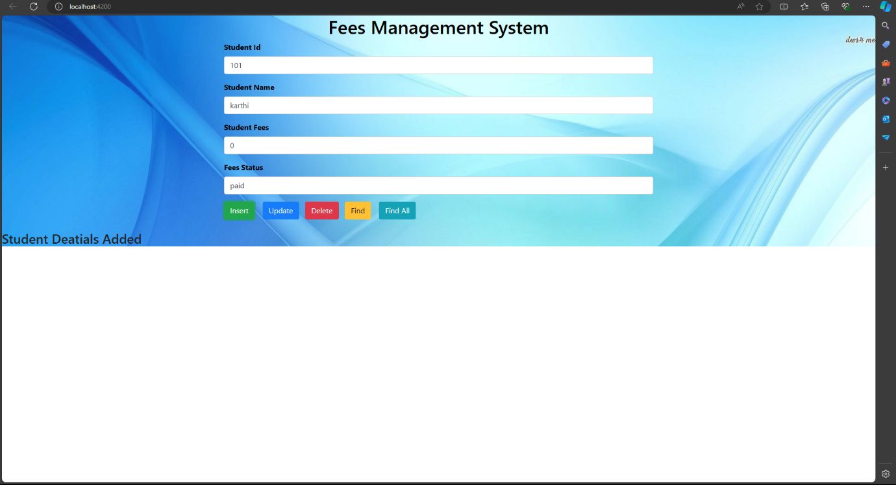

**3.Fees Management System _ After Insertion_JSON DB Screenshot:**

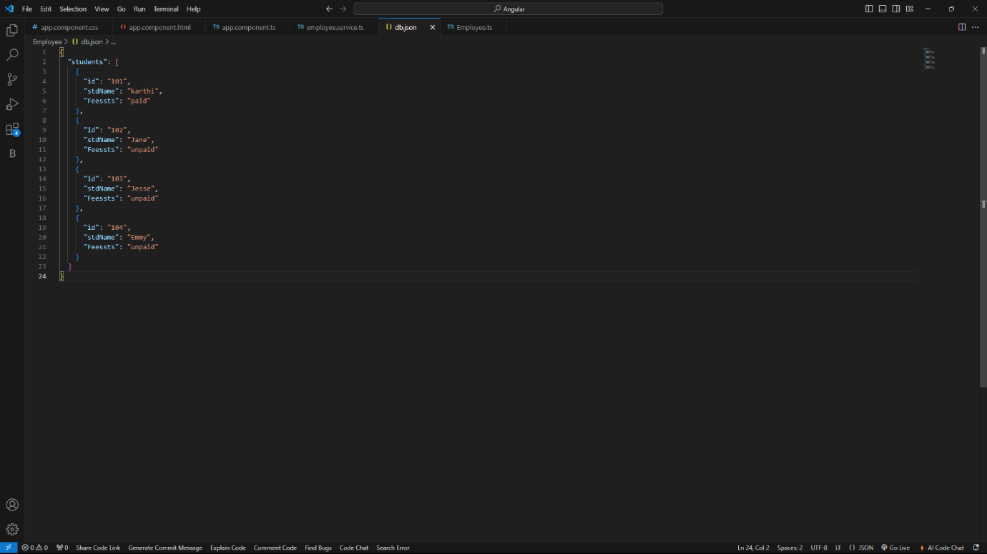

**4.** **Fees Management System _ Updating Screenshot :**

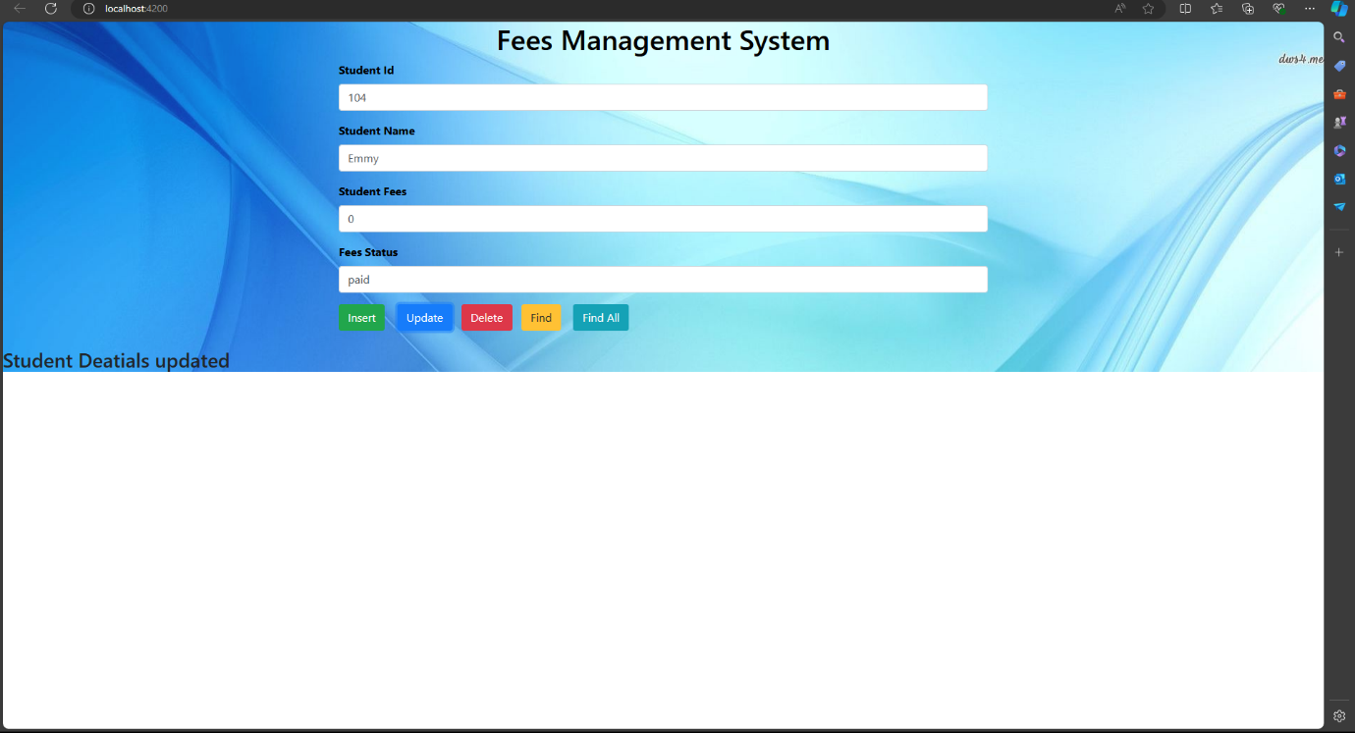

**5. Fees Management System _After Updating_JSON DB Screenshot :**

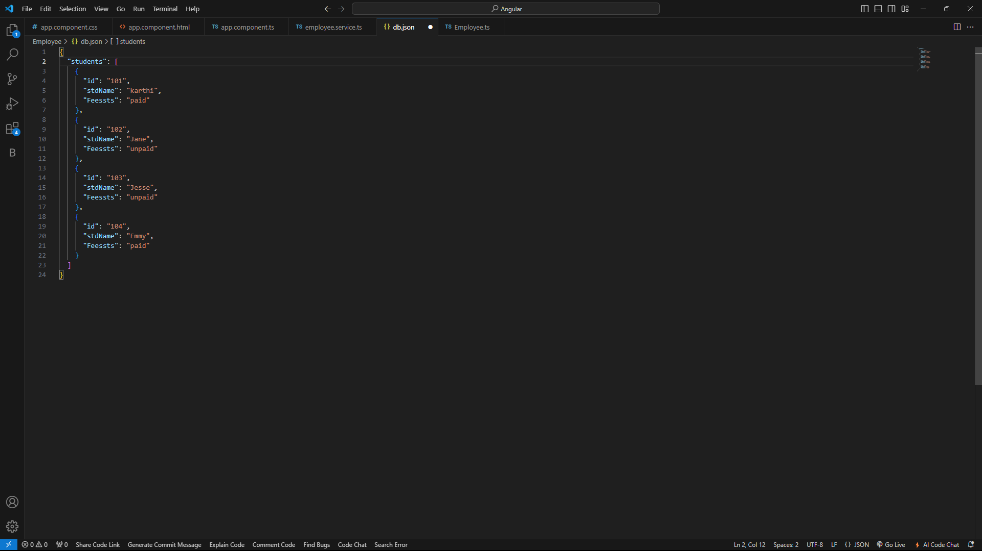

**6. Fees Management System _ Deletion Screenshot:**

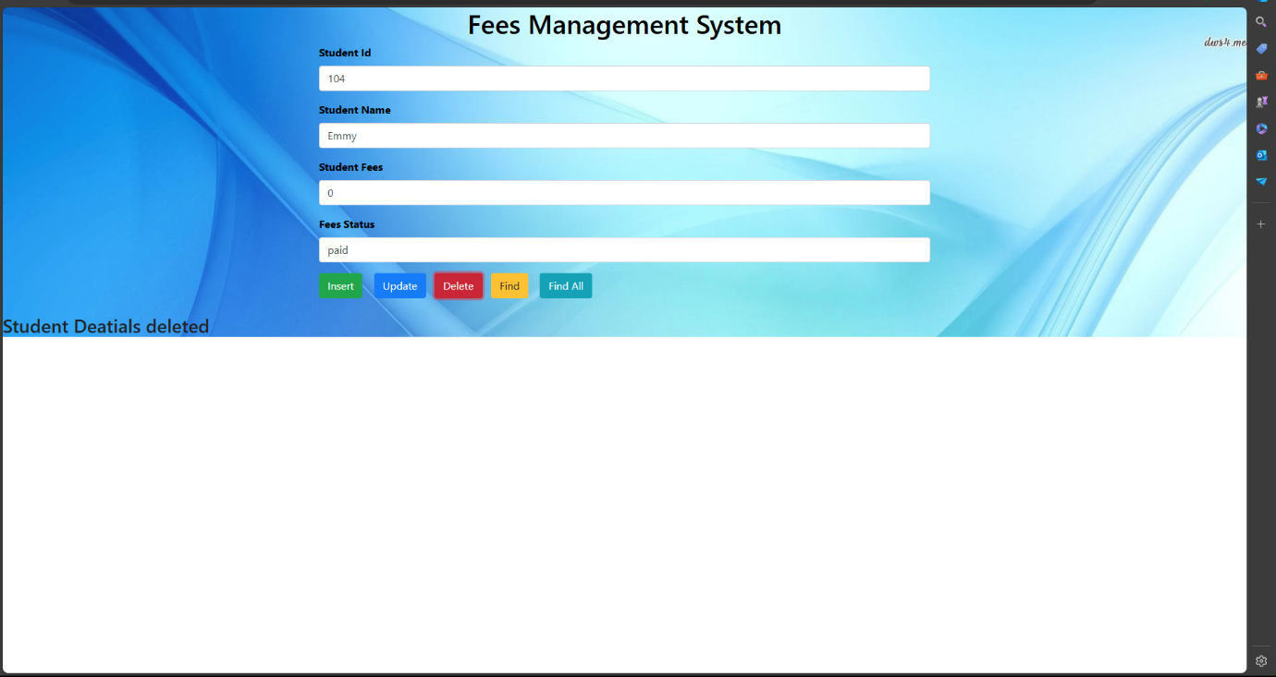

**7. Fees Management System _ After Deletion_JSON DB Screenshot :**

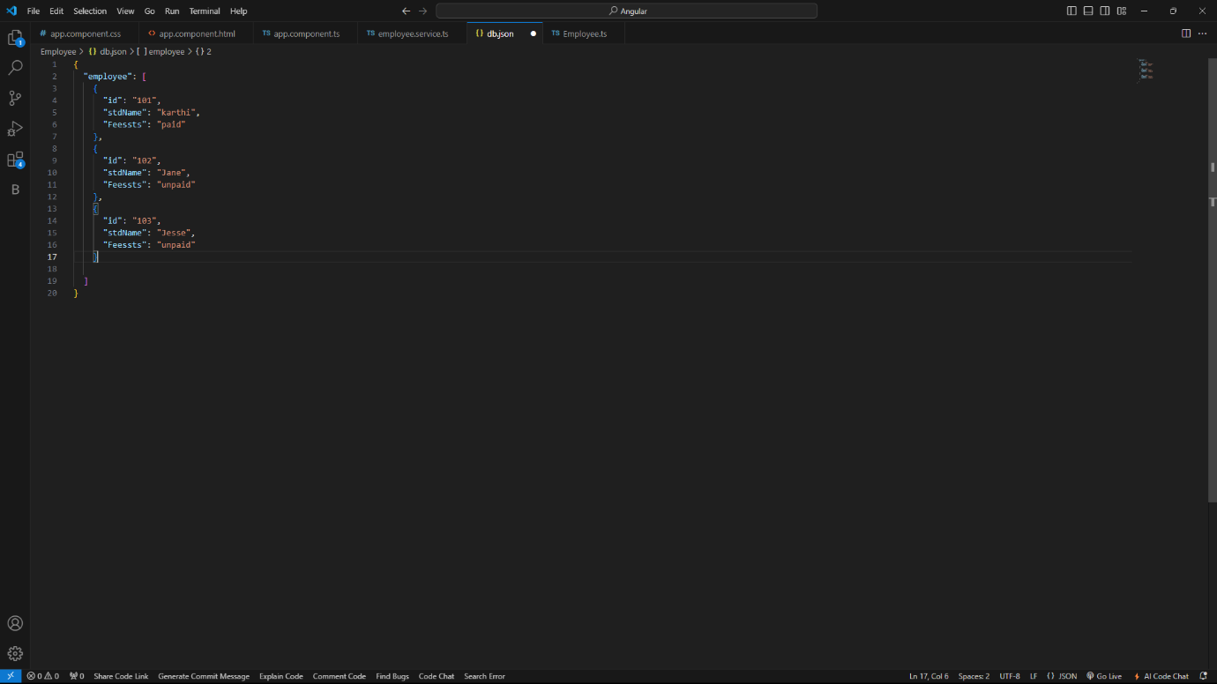

**8.**  **Fees Management System _ Finding Screenshot :**

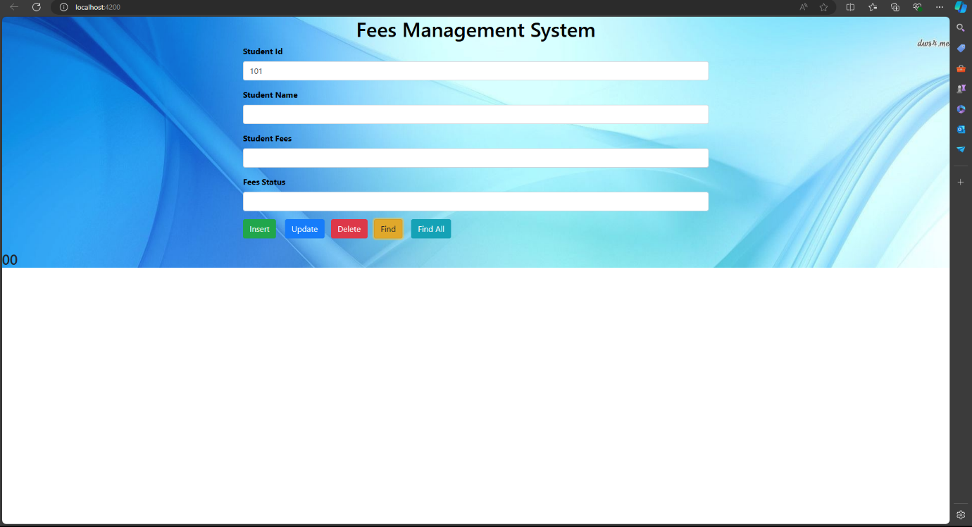

**9. Fees Management System _ Find All Screenshot :**

